**Part 1**

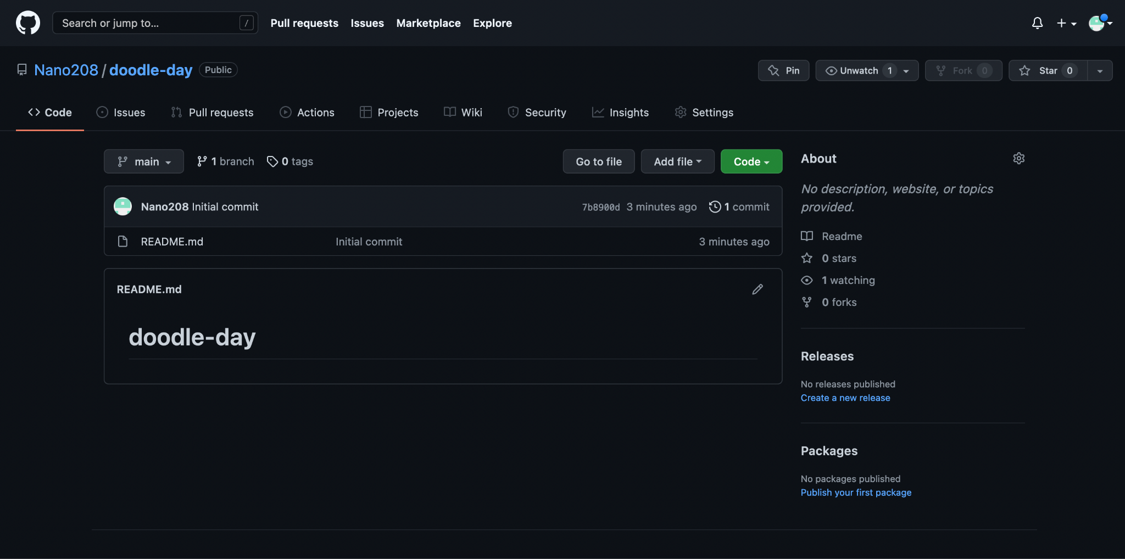

**Part 2**

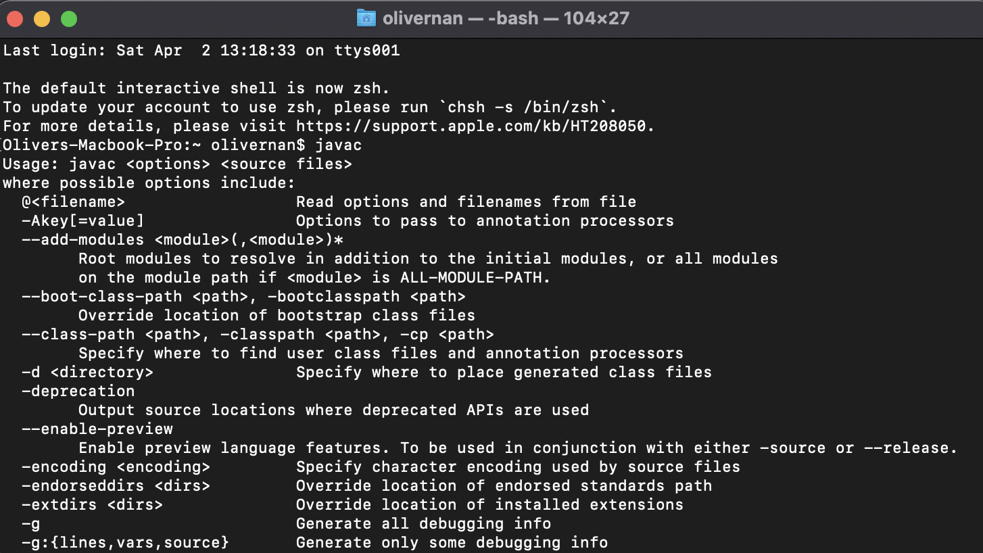

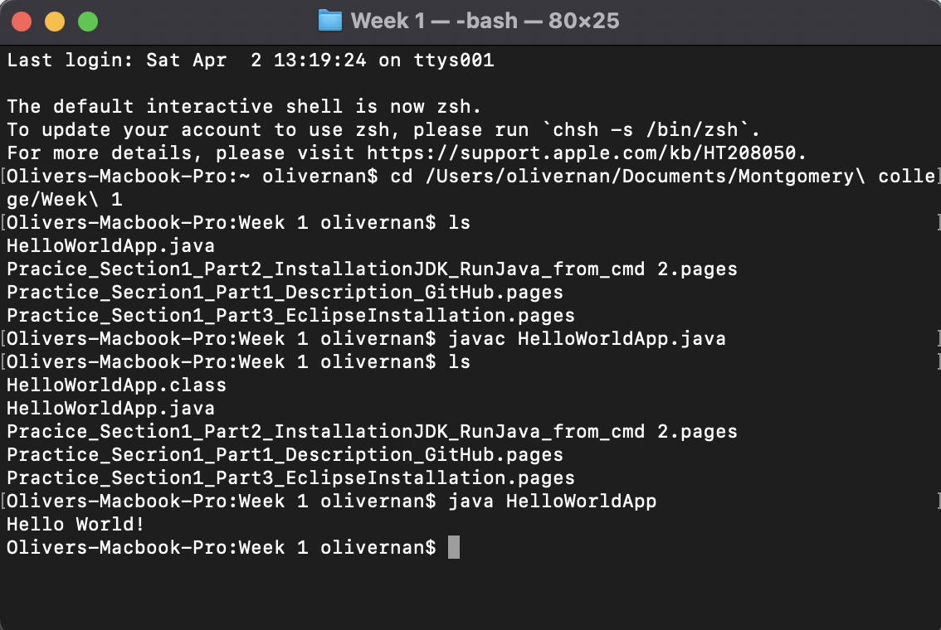

**Part 3**

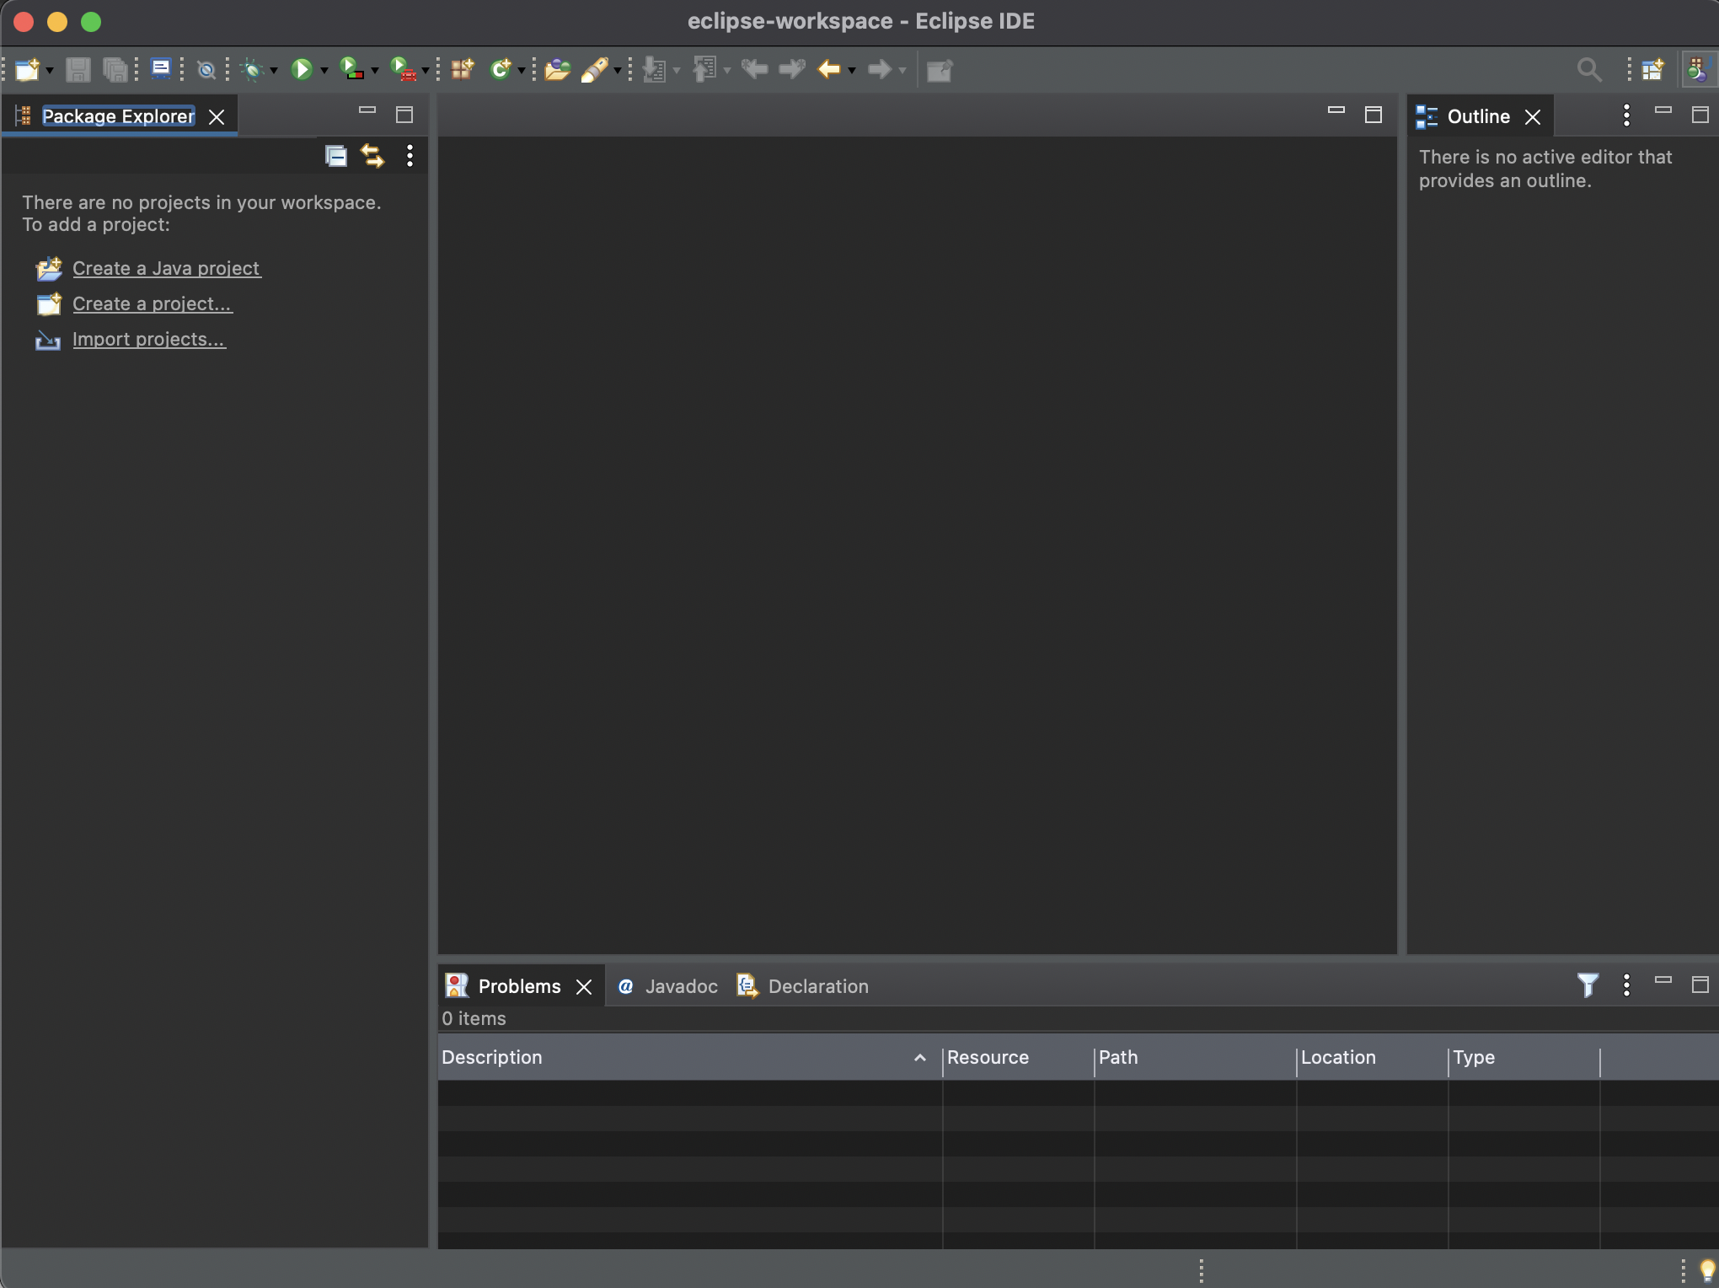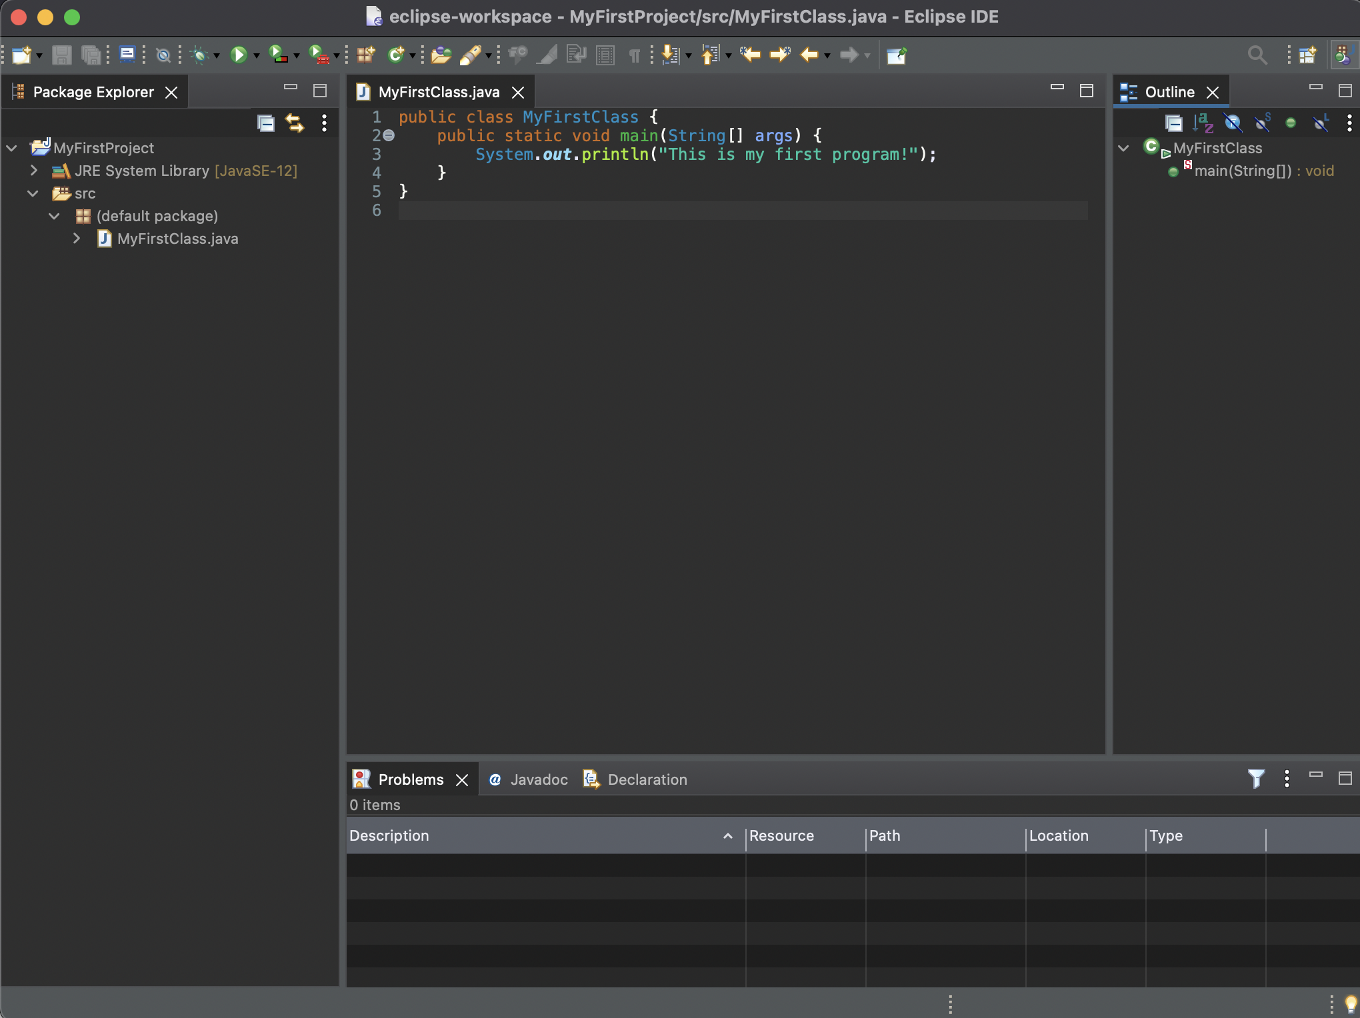

**Part 4**

**Vocab**

| Camel case | A naming convention to eliminate spaces in a name, but to ease readability with capitalization. |
| --- | --- |
| Switching the workspace | To change the different physical location onto which you will store and save your files. |
| A package | Stored inside a project, a mechanism for organizing Java classes into namespaces, or containers. |
| The main method | The method inside a class that runs when the class is compiled and ran. |
| A class | A construct that is used as a blueprint to create objects. Also a construct in which objects are created. |
| A perspective | An option to choose a combination of views and editors. |
| The edit and view areas | Areas within the Eclipse IDE that provide a way to navigate a hierarchy of information and allow modifications to elements. |

**Presentation-Turned in as a separate powerpoint file.**

**Pseudo code-**

Use scanner to read in input of gallons

Store the read in amount of gallons as a double/float

Multiple the stored gallons variable by 3.785

Store the resulting value as a new double/float (should be same storage type as the gallon variable)

Print out (Gallon) gallons is equal to (liters) liters

**Pseudocode made into actual code and ran in eclipse**

